Allows to create staging env. Similar to prod..

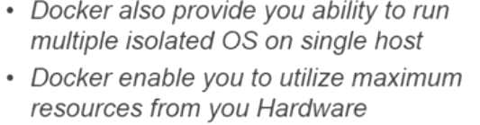

Virtualization: Dividing physical hardware logically/virtually.

3 vms-> 3 OS->3 kernels->memory, cpu --Application level

Kernel level virtualization🡪same kernel share..

**We will get FS in container…,But no kernel**

(no Guest OS, Direct APPs install)

Cat /etc/issue

/etc/init.d/docker status.

If I want fresh Ubuntu m/c for 15 min for test environment🡪 Docker gives u ability to create it.

Modes: Interactive..,as long you connect to docker..it lives..disconnect destroy.

Daemon mode: for longer mode..U can disconnect..Container will still be active.

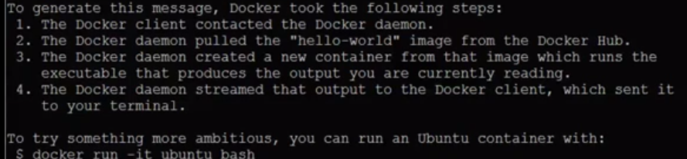docker run hello-world

Interactive mode:

docker run -it --name harish ubuntu /bin/bash

--name -> container name. imagenane(ubuntu) ct /etc/issue..

Unable to find image locally…get image from dockerhub..

This is like an OS similar to VM. Only difference is kernel will not be installed..

Whenever I exit, container will get destroyed.

docker run -it --name mysecond ubuntu /bin/bash

For this command, it didn’t download ubuntu image from dockerhub, it uses already downloaded image available locally of ubuntu

docker run -it --name mythird ubuntu /bin/bash

If fraction of second, container ready…Uses download image locally.

Docker ps🡪 How many containers currently running

Docker ps –a🡪 all container, even stopped

Docker rm Cid/Cname🡪 delete containers

Docker images-> show images available

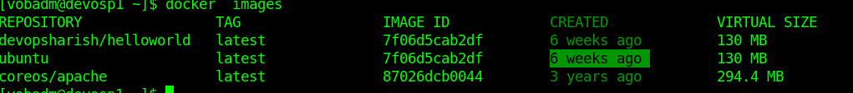

Created by docker/official guys 6 weeks ago…

Delete rmi imageid🡪delete image

If an image is attached to Container.. First we need to remove container & then only can remove image..

|  |
| --- |
| [vobadm@devosp1 ~]$ docker ps -a  CONTAINER ID IMAGE COMMAND CREATED STATUS PORTS NAMES  ea86591b5b04 centos "/bin/bash" 6 seconds ago Exited (0) 2 seconds ago secondcentos  b959fb46ff39 centos "/bin/bash" 47 seconds ago Exited (0) 44 seconds ago firstcentos  🡪 created 2 containers firstcentos, secondcentos out of image centos  [vobadm@devosp1 ~]$ docker images  REPOSITORY TAG IMAGE ID CREATED VIRTUAL SIZE  centos latest 6cc2eba34ef6 5 days ago 192.5 MB  [vobadm@devosp1 ~]$ docker rmi 6cc2eba34ef6  Error response from daemon: Conflict, cannot delete 6cc2eba34ef6 because the container ea86591b5b04 is using it, use -f to force  Error: failed to remove images: [6cc2eba34ef6]  🡪 If an image is attached to Container.. First we need to remove container & then only can remove image..  Here: Image 6cc2eba34ef6(centos) is attached to 2nd centos container ea86591b5b04(secondcentos)  [vobadm@devosp1 ~]$ docker ps -a  CONTAINER ID IMAGE COMMAND CREATED STATUS PORTS NAMES  ea86591b5b04 centos "/bin/bash" 56 seconds ago Exited (0) 53 seconds ago secondcentos  b959fb46ff39 centos "/bin/bash" About a minute ago Exited (0) About a minute ago firstcentos  [vobadm@devosp1 ~]$ docker rm ea86591b5b04  ea86591b5b04  🡪 Delete 2nd container(secondcentos)  [vobadm@devosp1 ~]$ docker rmi 6cc2eba34ef6  Error response from daemon: Conflict, cannot delete 6cc2eba34ef6 because the container b959fb46ff39 is using it, use -f to force  Error: failed to remove images: [6cc2eba34ef6]  🡪 Try deleting Image 6cc2eba34ef6(centos).., is attached to 1st centos container 6cc2eba34ef6 (firstcentos)  [vobadm@devosp1 ~]$ docker rm b959fb46ff39  b959fb46ff39  🡪 Delete 1st container(firstcentos)  [vobadm@devosp1 ~]$ docker rmi 6cc2eba34ef6  Untagged: centos:latest  Deleted: 6cc2eba34ef629ced34f934f0a4c2eacb5f74e3945b21697ab22fc4bb2f12e6f  Deleted: c31ce3acffa8f3e1d7217b7773d9197737103d3bf4beae72027cc3d1e71a3c9c  Deleted: af3c2e01824e4d1a26d442587dc285ea216ea82041339f42ed5d1d4e6f9a73ab  🡪 Delete image now  **Sceneria-2:**  [vobadm@devosp1 ~]$ docker rmi -f 6cc2eba34ef6  Untagged: centos:latest  Deleted: 6cc2eba34ef629ced34f934f0a4c2eacb5f74e3945b21697ab22fc4bb2f12e6f  Deleted: c31ce3acffa8f3e1d7217b7773d9197737103d3bf4beae72027cc3d1e71a3c9c  Deleted: af3c2e01824e4d1a26d442587dc285ea216ea82041339f42ed5d1d4e6f9a73abForcefully deleted image forcefully, without deleting container  [vobadm@devosp1 ~]$ docker ps -a  CONTAINER ID IMAGE COMMAND CREATED STATUS PORTS NAMES  bd697d5cd184 centos "/bin/bash" 3 minutes ago Exited (127) 52 seconds ago firstcentos  🡪container exists , even image deleted  [vobadm@devosp1 ~]$ docker run -it bd697d5cd184  Unable to find image 'bd697d5cd184:latest' locally  🡪 It downloads image from hub, If I run container whose image doesn’t exists |

[vobadm@devosp1 ~]$ docker run -it --name firstcentos centos /bin/bash

Unable to find image 'centos:latest' locally

latest: Pulling from centos

af3c2e01824e: Extracting [======================> ] 31.2 MB/70.46 MB

c31ce3acffa8: Download complete

6cc2eba34ef6: Download complete

🡪 Now if I run container again, after deleting centos image completely..It downloads from dockerhub..

Container run as daemon.. Detachable mode.

We can exit conatiner also..and enter into it also

docker run -t -d --name firstcentos_detach centos /bin/bash

docker ps

(firstcentos container running)

-d🡪 daemon/detachable mode..

When we install docker engine, it will setup n/w (docker0) with pool 172.17.42.1

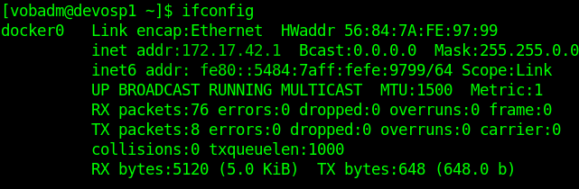

When we create container..docker daemon will setup ip from this pool..

When we start container.., through dhcp container will get assigned IP from pool in a sequence.

For 1st containers🡪2, 2nd containers🡪3,….254 containers🡪 255 get assigned.

When conatiner is created, by default ssh is disabled..Need to install ssh package in it

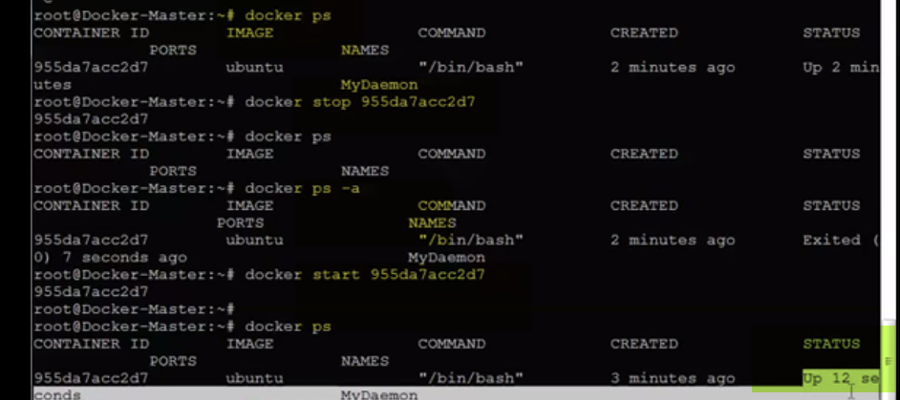

HOW EASY TO START/STOP VM or OS?...,just seconds

Docker exec: Run a command in a running container.

|  |
| --- |
| Run docker exec on a running container  First, start a container.  $ docker run --name ubuntu_bash --rm -i -t ubuntu bash  This will create a container named ubuntu_bash and start a Bash session.  Next, execute a command on the container.  $ docker exec -d ubuntu_bash touch /tmp/execWorks  This will create a new file /tmp/execWorks inside the running container ubuntu_bash, in the background.  Next, execute an interactive bash shell on the container.  $ docker exec -it ubuntu_bash bash  This will create a new Bash session in the container ubuntu_bash.  Try to run docker exec on a paused container  If the container is paused, then the docker exec command will fail with an error:  $ docker pause test  test  $ docker ps  CONTAINER ID IMAGE COMMAND CREATED STATUS PORTS NAMES  1ae3b36715d2 ubuntu:latest "bash" 17 seconds ago Up 16 seconds (Paused) test  $ docker exec test ls  FATA[0000] Error response from daemon: Container test is paused, unpause the container before exec  $ echo $?  1 |

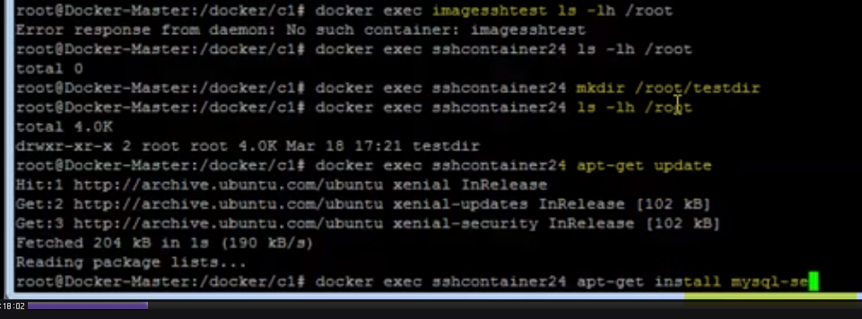

Install package using exec usinf docker API..

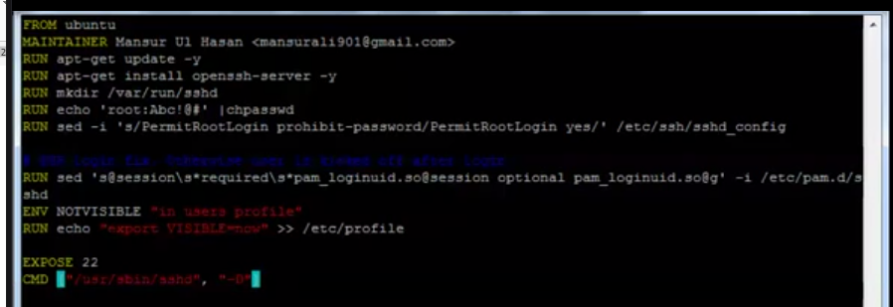

From Ubuntu: From which image we should I build

Maintainer

RUN apt-get -y update –y 🡪update repositories

RUN apt-get install –y openssh-server 🡪 install ssh

RUN Mkdir /var/run/sshd

RUN echo ‘root:root111’| chpasswd 🡪 set password

ENV NOTVISIBLE “in usersprofile”

RUN echo “export VISIBLE=now”>>/etc/profile

EXPOSE 22

CMD[“/usr/sbin/sshd”, “-D”] 🡪 When we start container some process should start

Using Dockerfile, I can setup stage/Prod env..

Build image:

Docker build –t <imagename> Dockerfile

Map base machine port with container port

Ex; For ssh 22 port of container, if we need accessibility.. map port with Base m/c port

docker run –t -d --name Contname -p 24:22 ubuntu

Contname-> containername

Ubuntu-> imagename

docker exec Contname ps aux

docker exec Contname cat /etc/sshd/sshd_conf





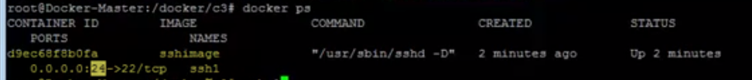

We can use port 24 alos to ssh